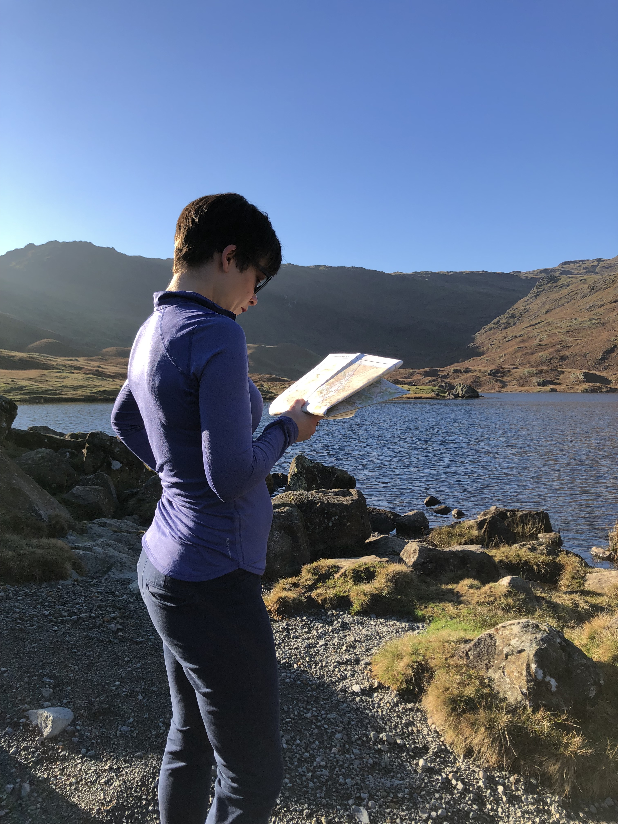

Hill walking skills course information sheet – split course

Course dates
Monday 30 March – 9.30 till 1.30 – indoor training
Monday 27 April – 10.00 till 2.00 – outdoor training

The course location
The indoor course will take place at St Peter’s Church in Harrogate, HG1 1PB. The outdoor course will take place near Grassington.

Course content
The indoor course will start with a coffee or tea and then we cover the following;
- Map symbols, colours and codes
- Grid references
- Contour lines
- Distance on the map
- How to use a compass
- Navigational techniques
- Some basic first aid
- What to do in an emergency

The outdoor session will include:
- Pacing
- How to judge distance using the time
- Aiming off using a bearing
- How to use an attack point
- Leap frogging in poor visibility
- Thumbing
- How to use a compass to recognise places on the map

Course fee
£45.00
Included in the fee;
- OL2 maps
- Compasses
- Coffee, tea and milk
- Training booklets
- Yoga mats (for kneeling and first aid practice)

Caroline Jackson MA – PGCE - HML
caroline@lingoexplore.co.uk
www.lingoexplore.co.uk

